Before running the program, save the folder somewhere memorable



Next, open Citrix Workspace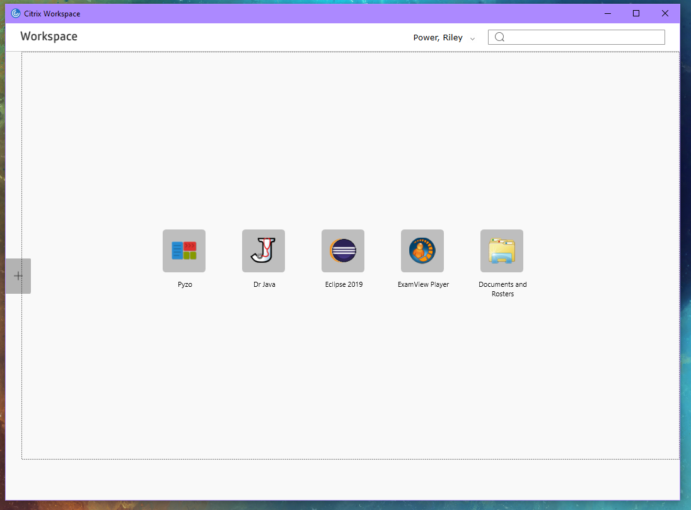

Click the plus icon, navigate to Programming > Eclipse 2019 and click on it

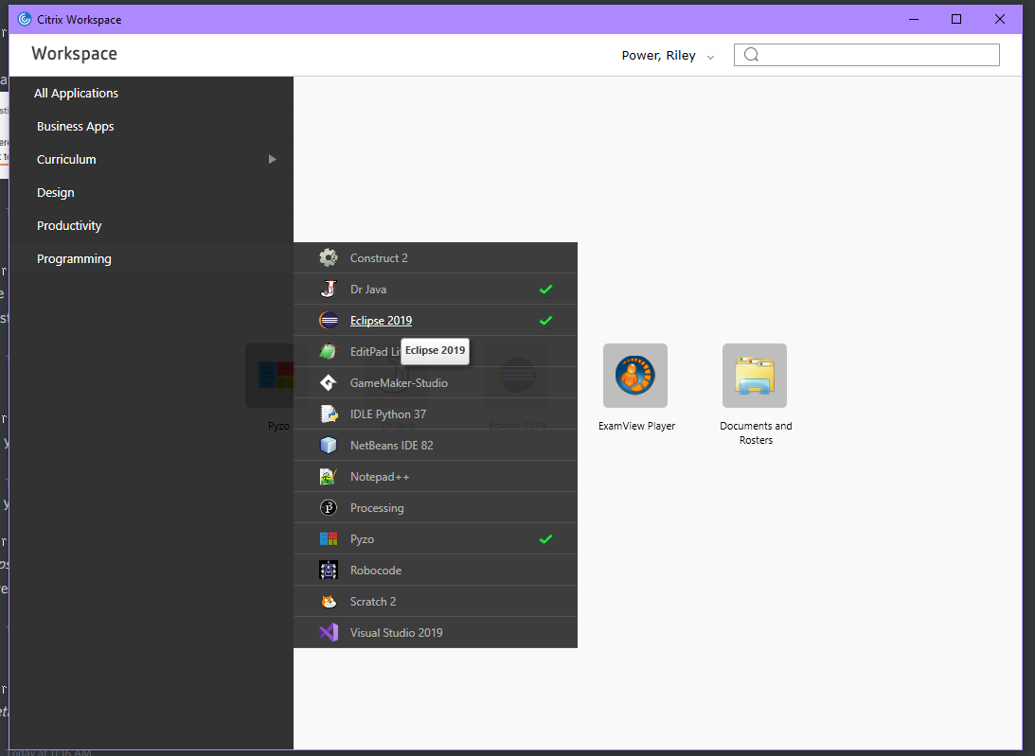

Eclipse should now begin to load

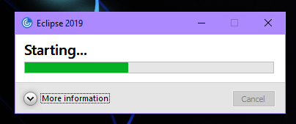

Set your workspace to the folder where you saved your menu folder, not the menu folder itself

For example, I saved it to H:\Menu so I set the workspace to H:\

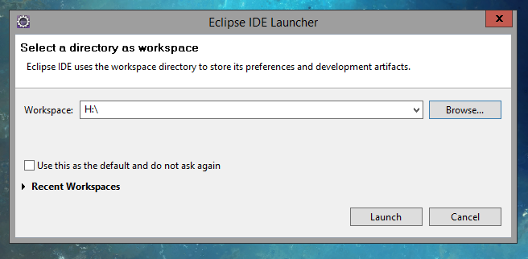

The Eclipse Workspace should now be visible

Navigate to Window > Show View > Project Explorer and select it

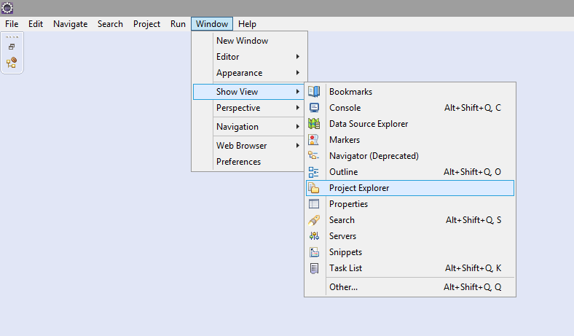

Nothing has happened yet and that is because it is still minimized, to solve this click on the maximize button.

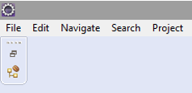

Next, in the Project Explorer, navigate to Menu > src > Main.java

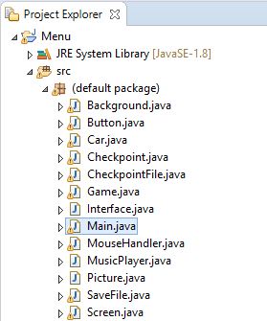

Now Navigate to Run > Run and select it

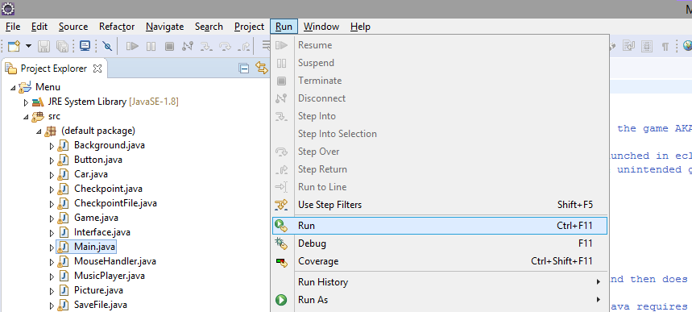

Now the game should open!

Keep in mind it is much preferred to run eclipse locally on your machine, rather than on Citrix as Citrix essentially streams the game to you, making it appear compressed and at a low frame rate

